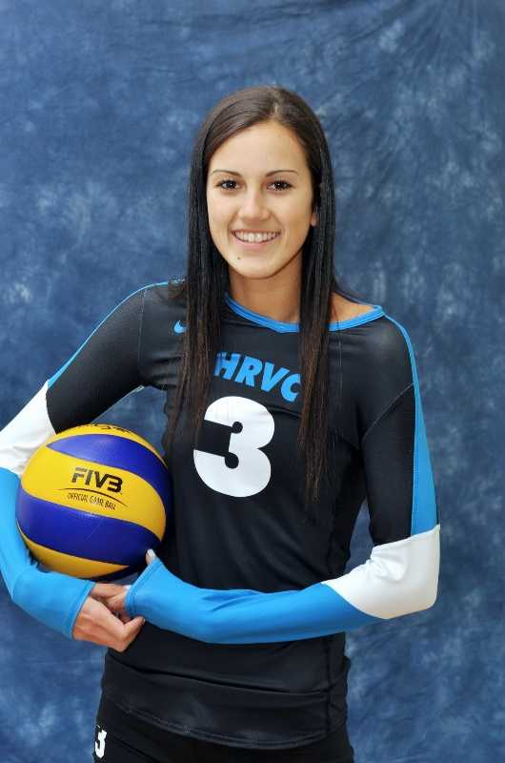
PERSONAL INFORMATION

Address: [Address, City, ON, Canada, A1A 1A1]

Telephone: [###-###-####]

Email: [email@address.com]
Player Picture Here

ATHLETIC INFORMATION

Height: [Height] Approach Jump: [Approach]

Weight: [Weight] Block Jump: [Block]

Standing Reach: [Reach]

Awards and Recognition:
- [Insert award here]
- [Insert award here]
- [Insert award here]
- [Insert award here]

ACADEMIC INFORMATION

High School: [School] GPA: [GPA]

Address: [Address, City, ON, Canada, A1A 1A1] SAT: [SAT or TBD]

Guidance Counselor: [Firstname Lastname (email@address.com; ###-###-####)]

Awards and Recognition:
- [Insert award here]
- [Insert award here]

TEAM INFORMATION

Current Team: Halton Hurricanes 15/16/18U Black

Coaches: Firstname Lastname (email@address.com; ###-###-####)

Firstname Lastname (email@address.com; ###-###-####)

Firstname Lastname (email@address.com; ###-###-####)

Tournament Schedule: CHANGE AS NEEDED

- Ontario Provincial Cup (November 29th)
- Ontario Challenge Cup (January 10th)
- Munciana MLK Challenge (January 17th-18th)
- SPVB Presidents’ Day Challenge
(February 14th-16th)
- Ontario Grand Prix (March 28th-29th)
- JVA World Challenge (April 10th-12th)
- 2015 Ontario Championships (April 24th-26th)
- 2015 Volleyball Canada Championships
(May 17th-19th)

